

Add a new starter in Kestrel HR
26 September 2026 · 13 steps
Yellow box = click here. The magnified panel shows the same spot up close.

✍ NOTE · Step 1

Before you start
- You need the HR Advisor role in Kestrel HR.
- Have the signed offer letter to hand: the name, department and contract type must match it.
- Practise with test data only, never a real person's details.
Policy: Onboarding and induction procedure, v3.2

Step 2 — Complete the following steps
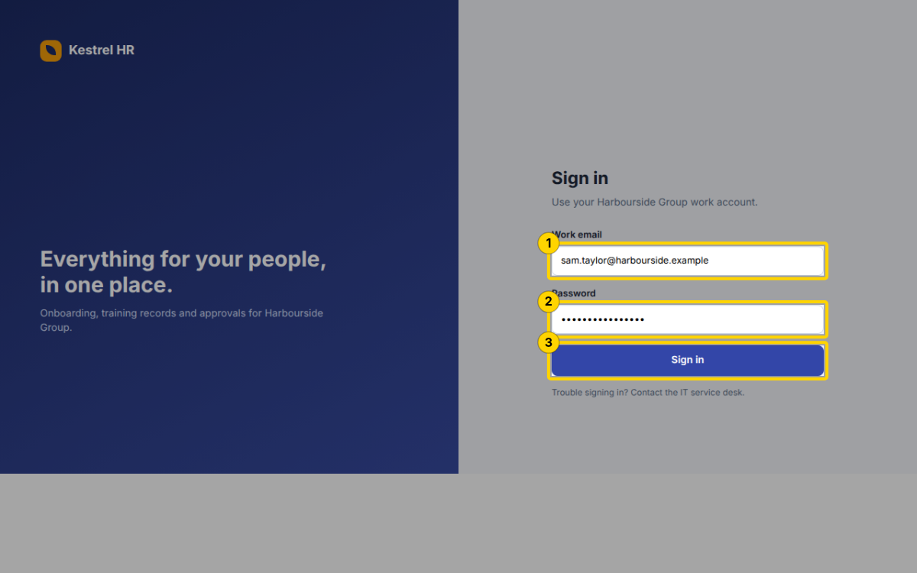
1. Enter sam.taylor@harbourside.example in Work email
2. Enter your Password
3. Click the Sign in button
Sign in · Kestrel HR · http://hr.harbourside.example:8800/ · textbox · 26 Sept 2026, 10:49

Step 3 — In the menu, click Onboarding
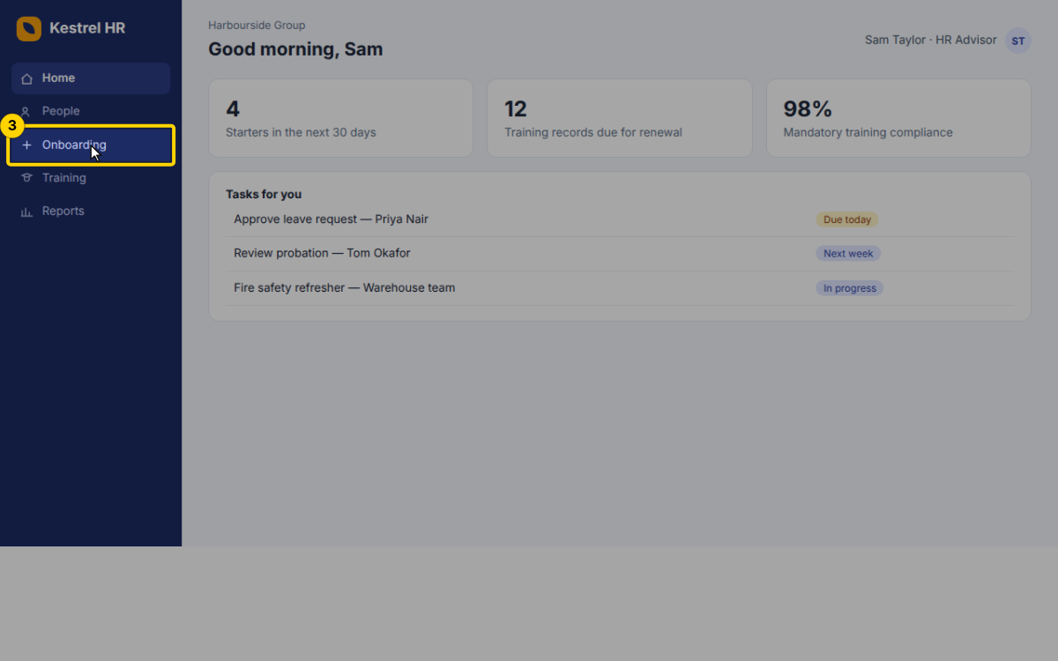
Step 3 · Result
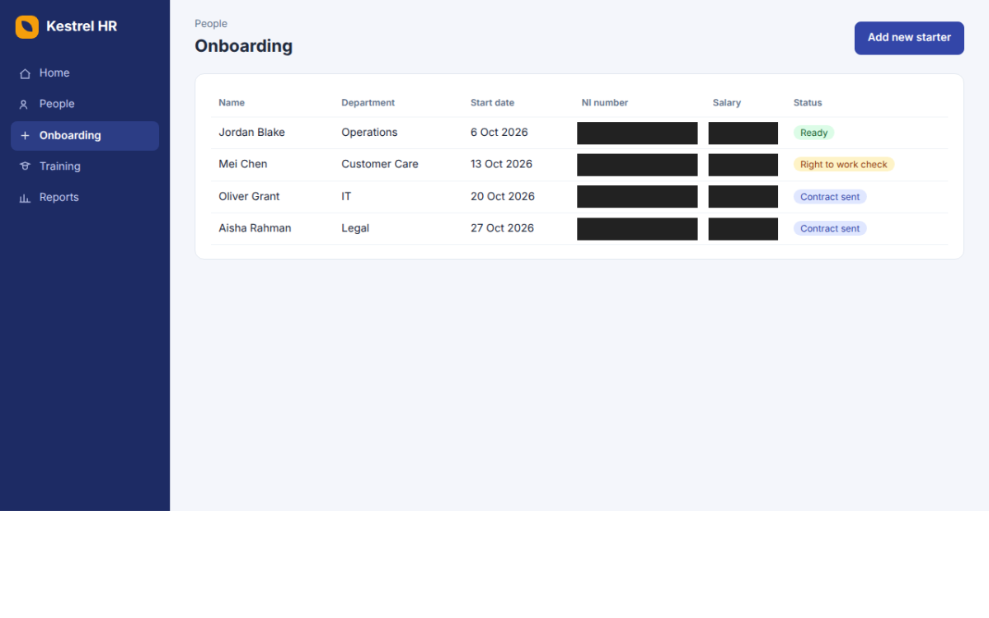
Home · Kestrel HR · http://hr.harbourside.example:8800/#home · link · 26 Sept 2026, 10:49

Step 4 — Click the Add new starter button
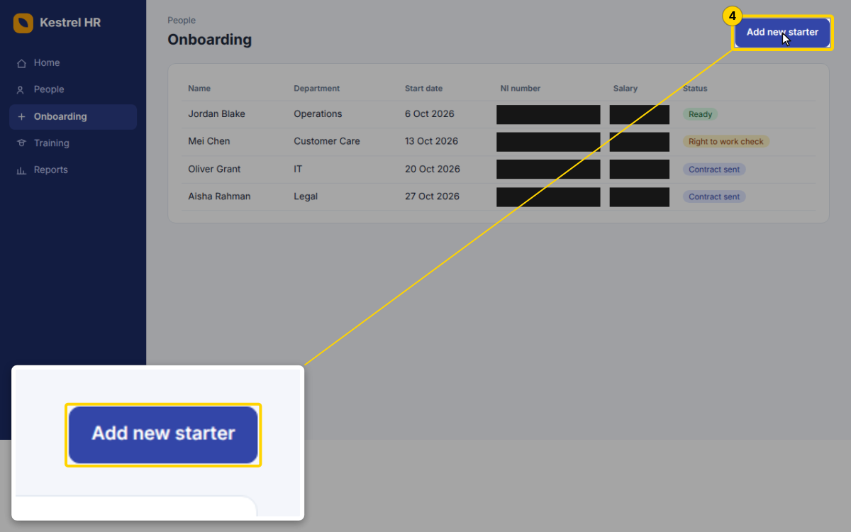
Onboarding · Kestrel HR · http://hr.harbourside.example:8800/#onboarding · button · 26 Sept 2026, 10:49

Step 5 — Complete the following steps
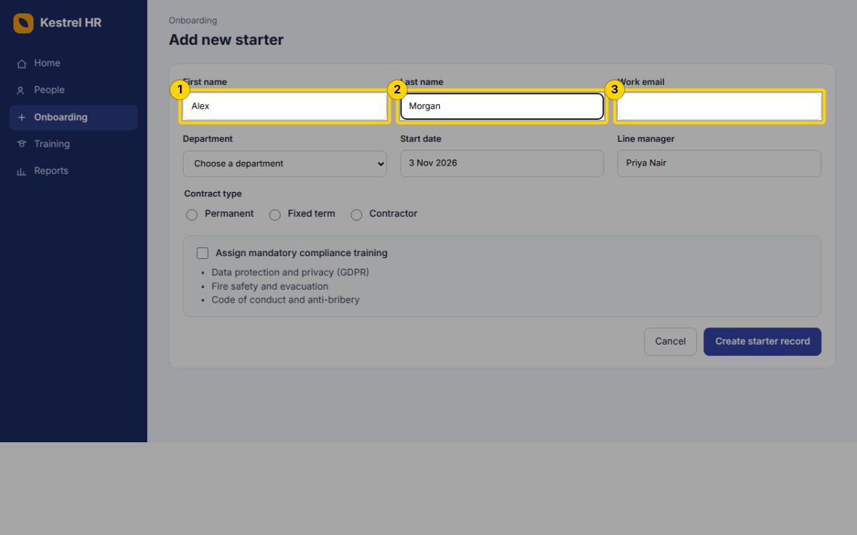
1. Enter Alex in First name
2. Enter Morgan in Last name
3. Enter alex.morgan@harbourside.example in Work email
Add new starter · Kestrel HR · http://hr.harbourside.example:8800/#onboarding/new · textbox · 26 Sept 2026, 10:49

Step 6 — Choose Finance from Department
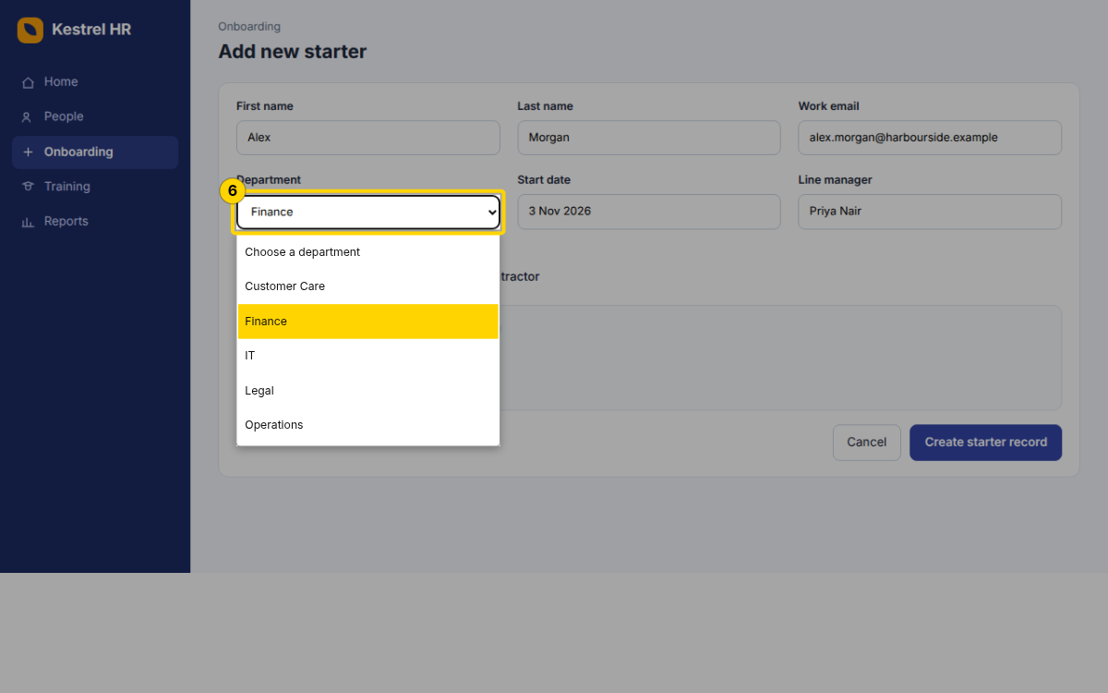
Step 6 · Result
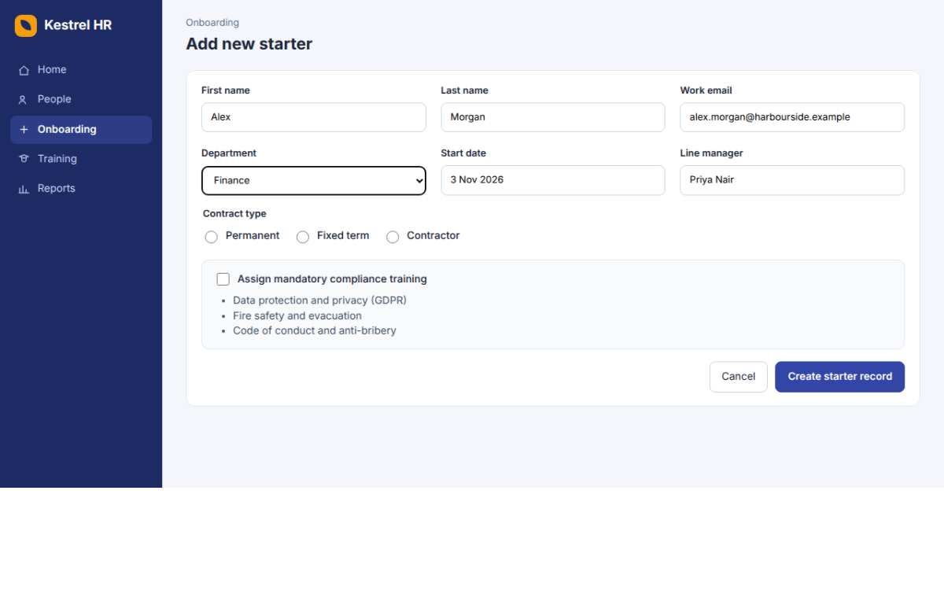
Add new starter · Kestrel HR · http://hr.harbourside.example:8800/#onboarding/new · combobox · 26 Sept 2026, 10:49

Step 7 — Under Contract type, select Permanent
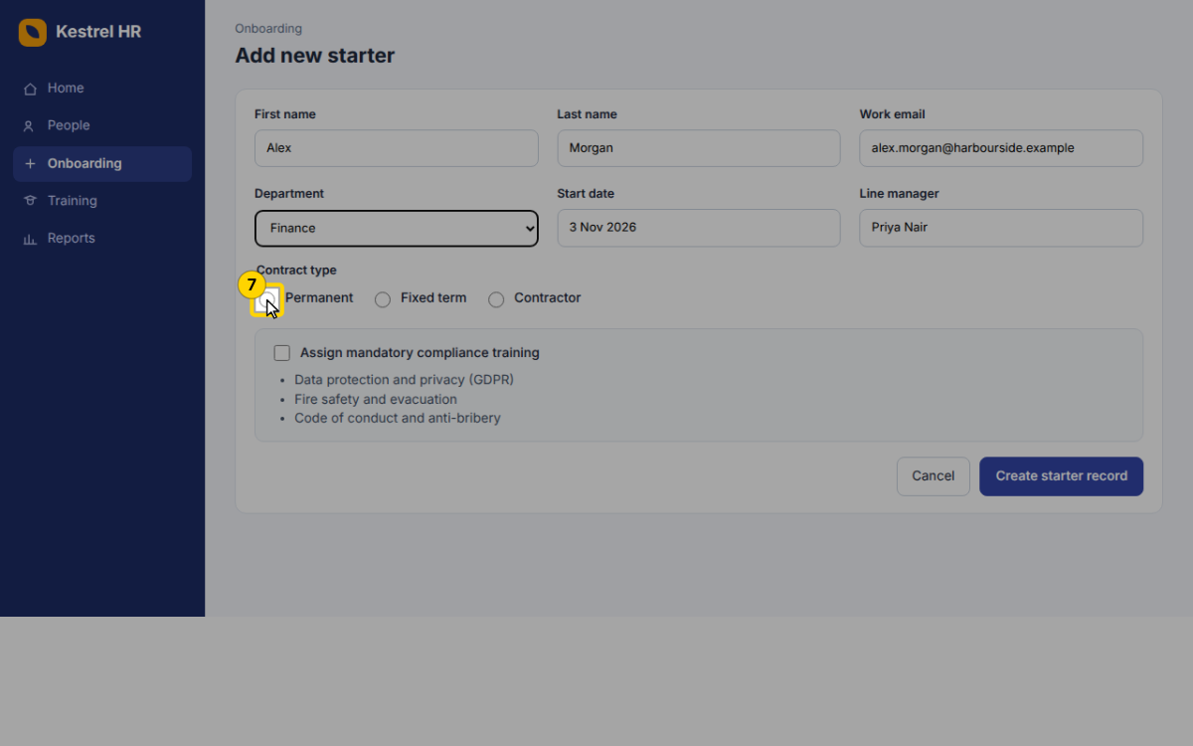
Add new starter · Kestrel HR · http://hr.harbourside.example:8800/#onboarding/new · radio · 26 Sept 2026, 10:50

Step 8 — Tick Assign mandatory compliance training
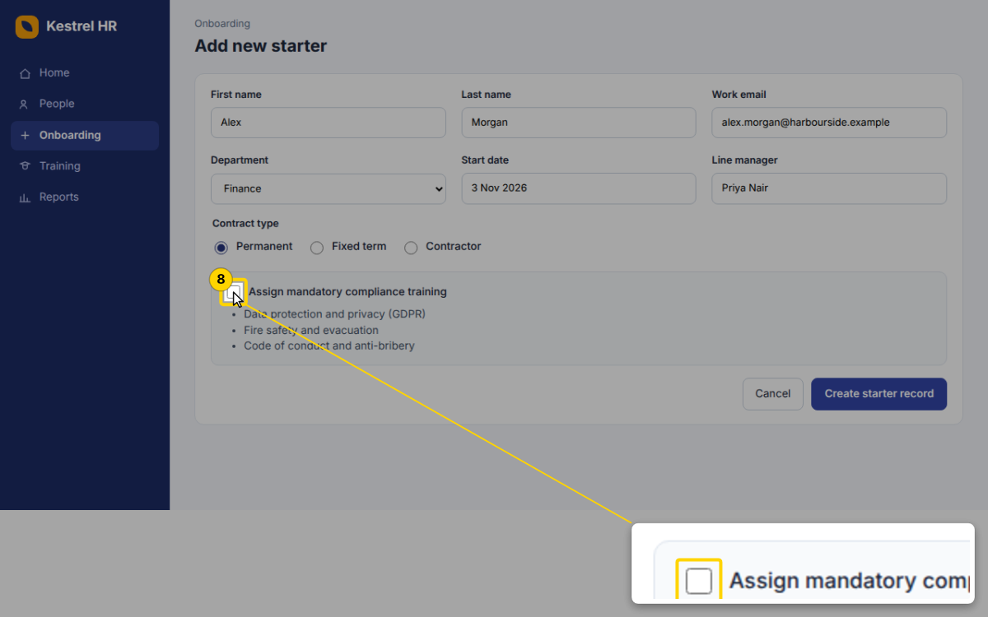
Add new starter · Kestrel HR · http://hr.harbourside.example:8800/#onboarding/new · checkbox · 26 Sept 2026, 10:50

Step 9 — Click the Create starter record button
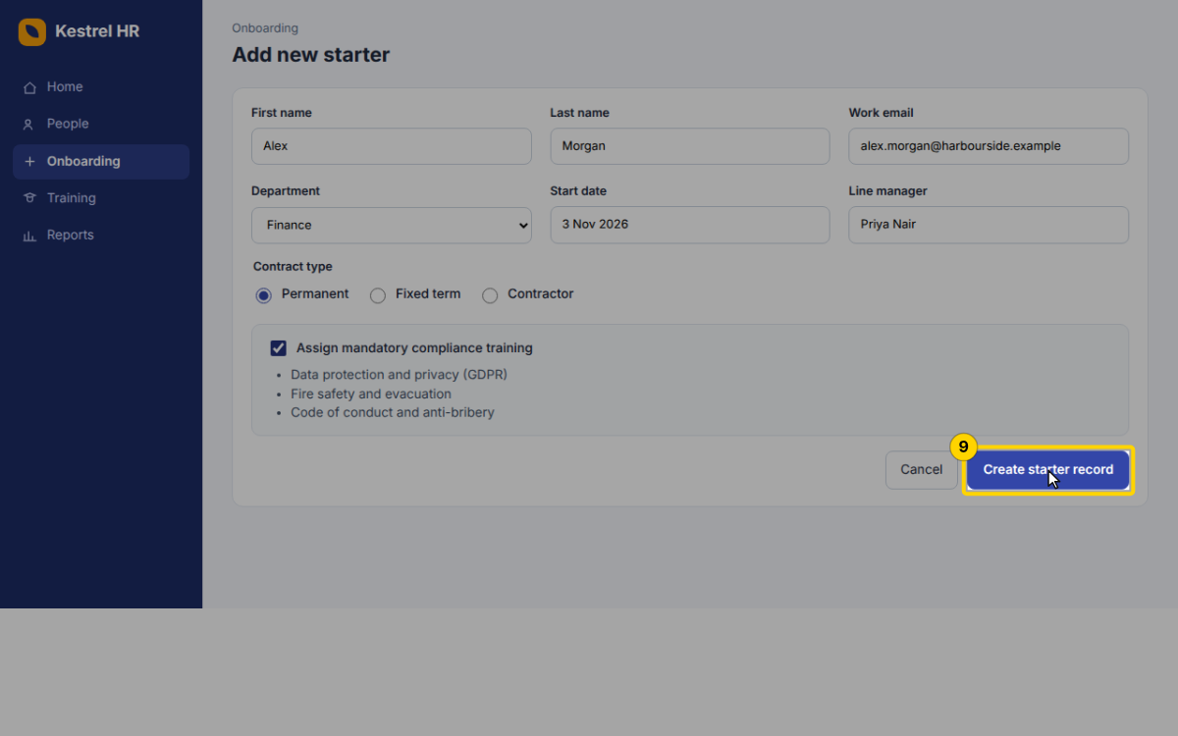
Add new starter · Kestrel HR · http://hr.harbourside.example:8800/#onboarding/new · button · 26 Sept 2026, 10:50

Step 10 — In the Confirm new starter dialog, click Confirm and send welcome pack
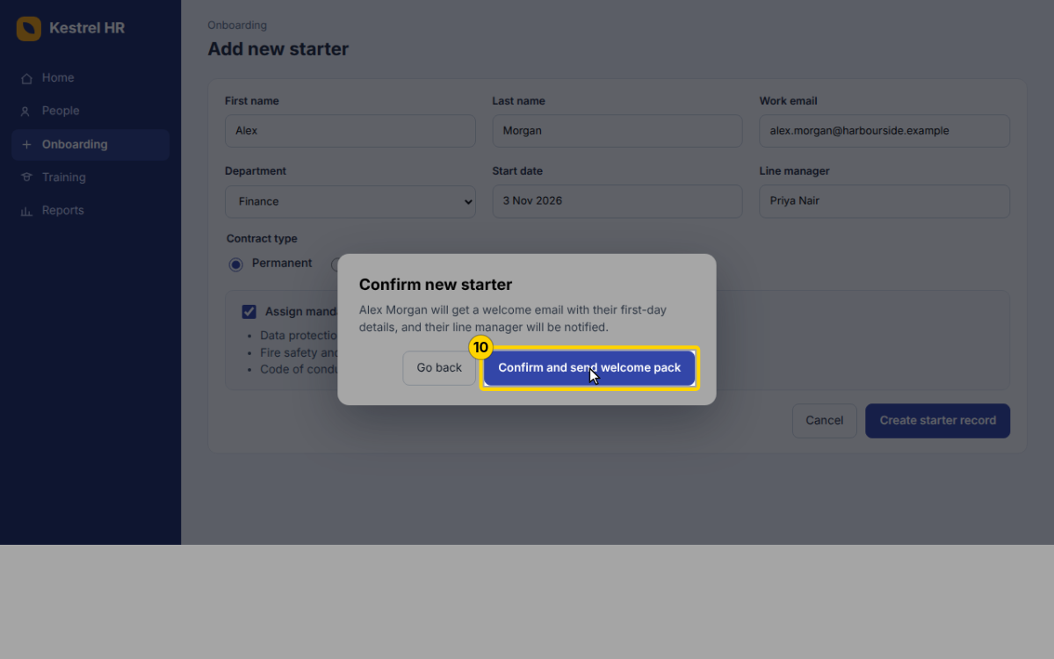
Add new starter · Kestrel HR · http://hr.harbourside.example:8800/#onboarding/new · button · 26 Sept 2026, 10:50

Step 11 — Check the green banner: the record number (KH-20417) confirms the starter record was created and the training was assigned
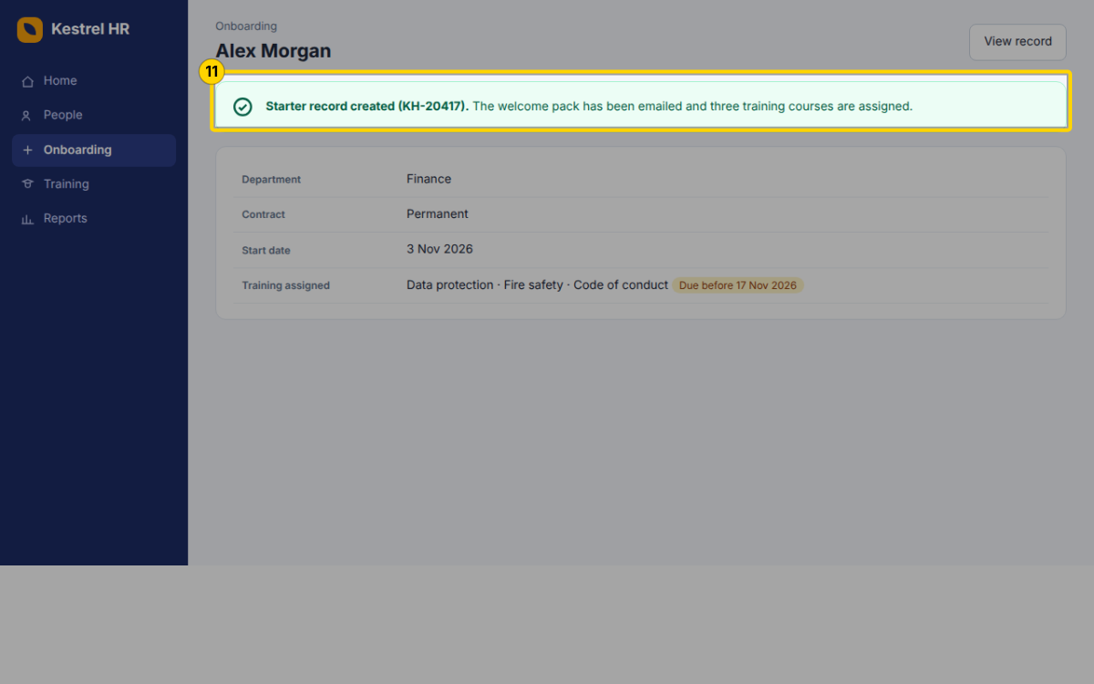
Alex Morgan · Kestrel HR · http://hr.harbourside.example:8800/#onboarding/KH-20417 · manual · 26 Sept 2026, 10:50

Step 12 — In Kestrel Badge Desktop, select the new starter and click Print badge
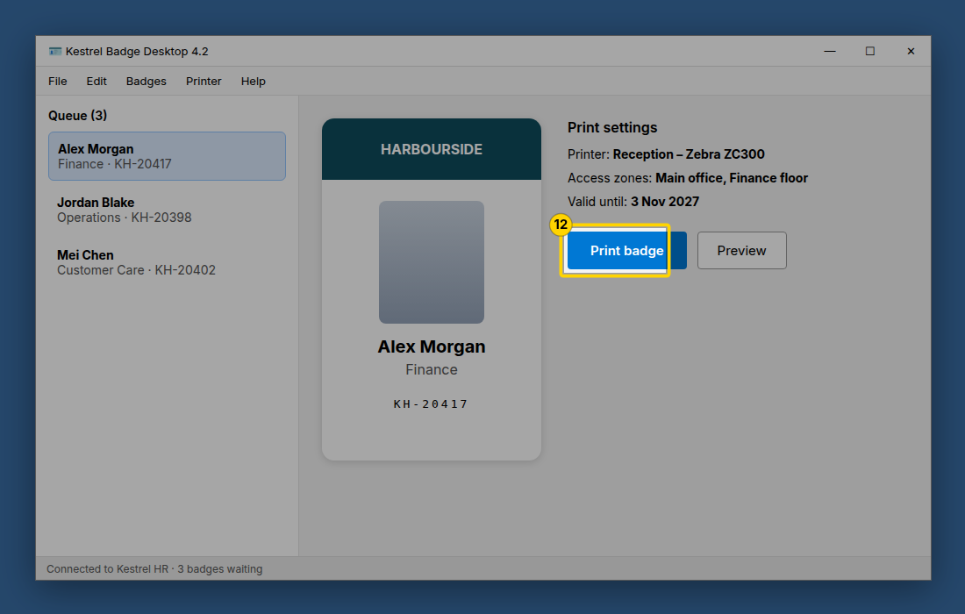
manual · 26 Sept 2026, 10:50

✍ NOTE · Step 13

What happens next
- Alex gets the welcome pack by email today.
- The three compliance courses are due before 17 Nov 2026; Kestrel HR sends reminders.
- Questions: people@harbourside.example

